Practical 1(A)

Range partitioning

Q1 write a query to create a tablespace for partition.



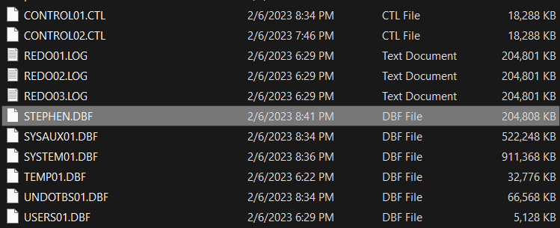

Q2 Write a query for range partitioning on tablespace. Values for partitioning:

* upto 2000
* upto 2005
* upto 2010

Columns for the table:

Product no varchar(2)

Year number(4)

Sales_Amt number(5)

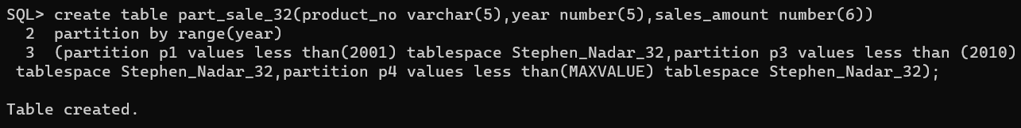

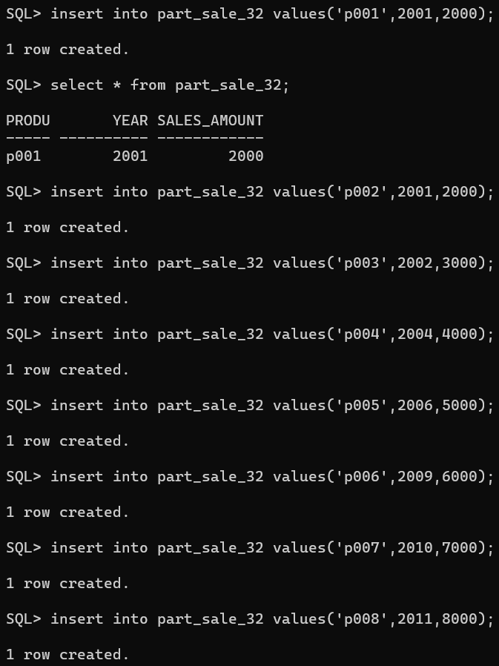

Q3 Write a query to display data partition-wise.

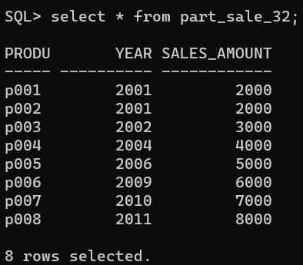

Q4 Write a query to drop partition p4.

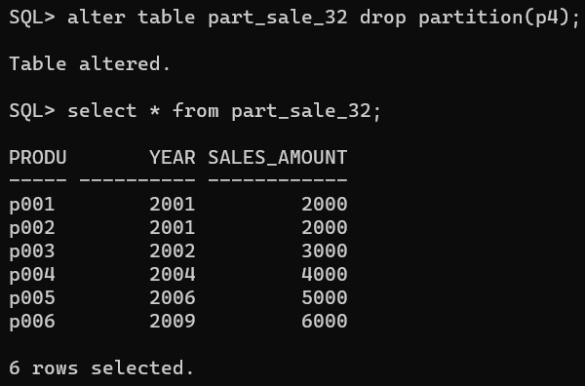

Q5 Write a query to add new partition p5 into part_sales_54 table which has the values less than 2015.

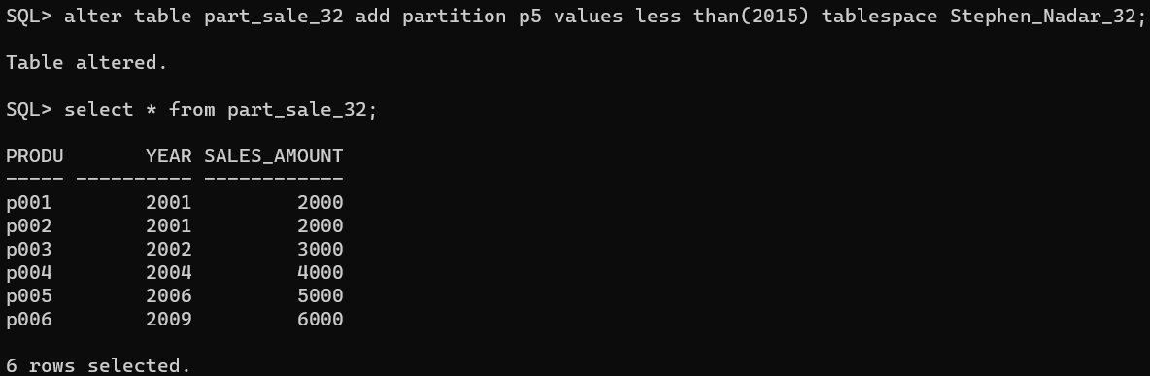

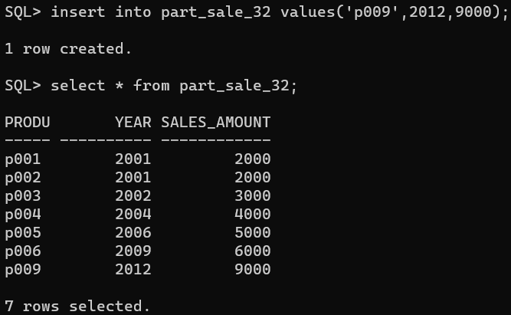

Q6 Write a query to rename the partition p5 to p4.

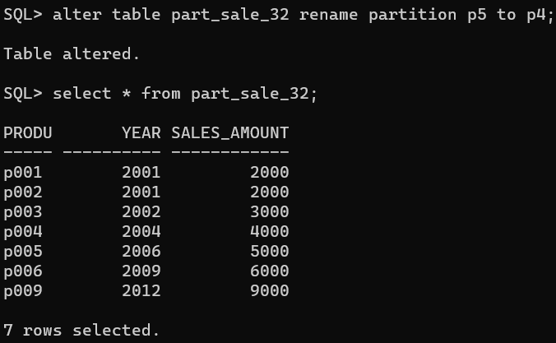

Q7 Write a query to merge partition P3 and P4 into partition P5.

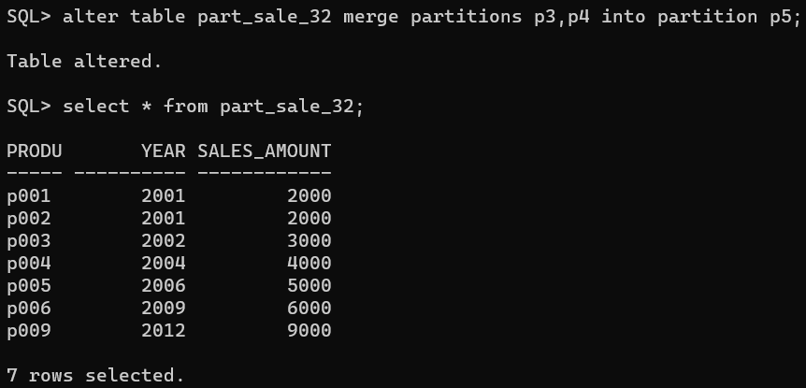

Q8 Write a query to split the partition P5 at range 2010 into partition p3 and partition P4.

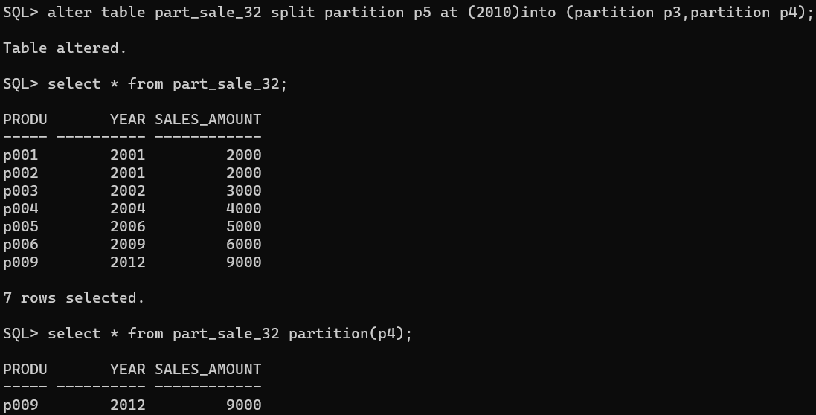

List partition

Q1) Write a query to create list partitioning on table dept_54 on columns dept  
_state and insert the values into the the table.

dept_54

columns:4

dept_no- p001,p002,p003,p004,p005,p006

dept_name=sales,IT,HR,finance,operations,marketing

budget=20,00,25000,10000,20000,10000,30000

dept_state=goa,Delhi,Kerala,haryana,assam,Maharashtra

partition east values(assam, west bengal)

west(goa,maharashtra)

north(delhi,haryana.jammu kashmir)

south(kerala,karnataka,tamil nadu)

(in table format)

Q.1 write a query for creating list partition on table department on column and insertion

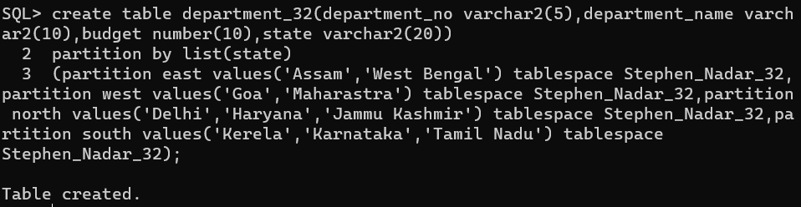

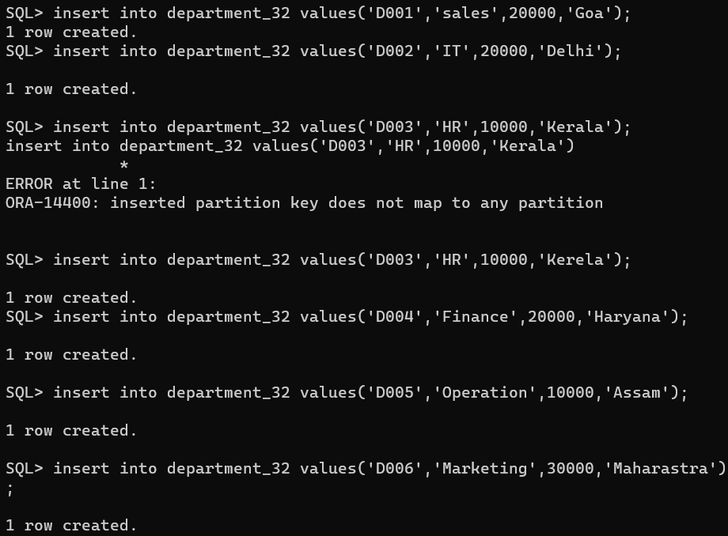

Q2 Write a query to display data partition-wise.

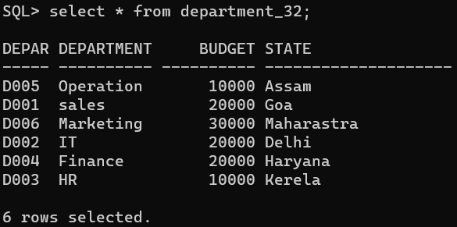

Q3 Write a query to add the new value for column dept_state.

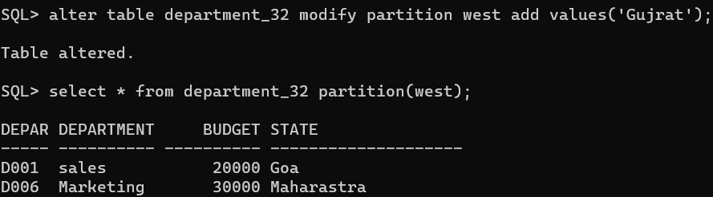

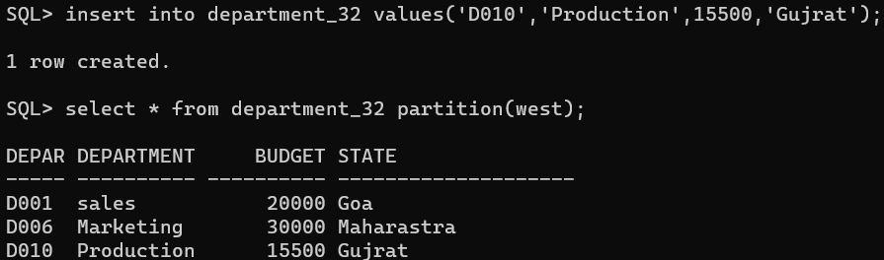

Q4 Write a query to merge partitions north and east as a north-east.

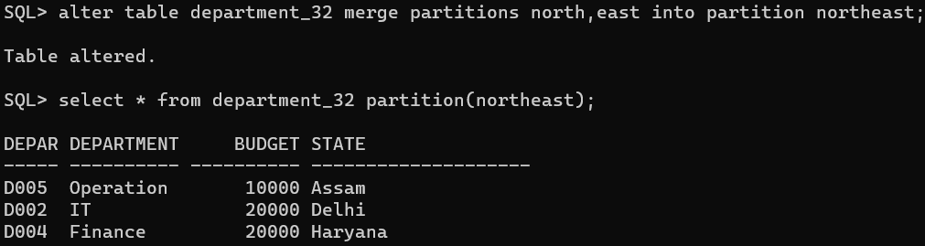

Q5 Write a query to split partitions north-east into north and east.

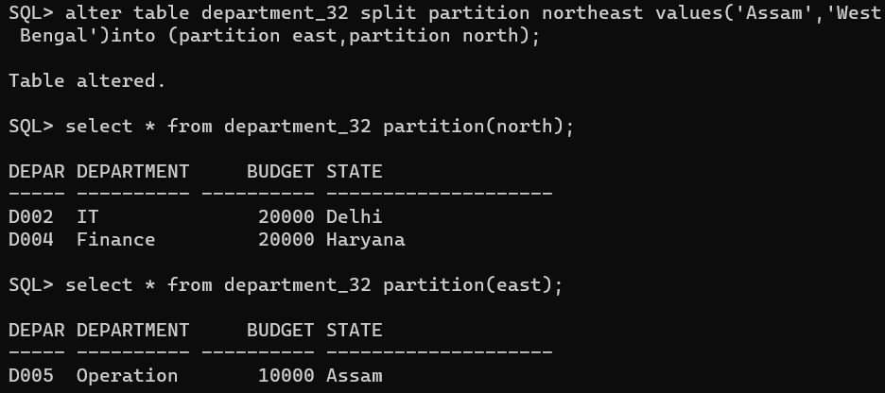

Practical 2

Implementation of analytical queries

1. Create table employee_65

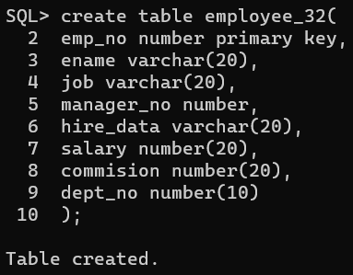

2. Insert record in employee_65

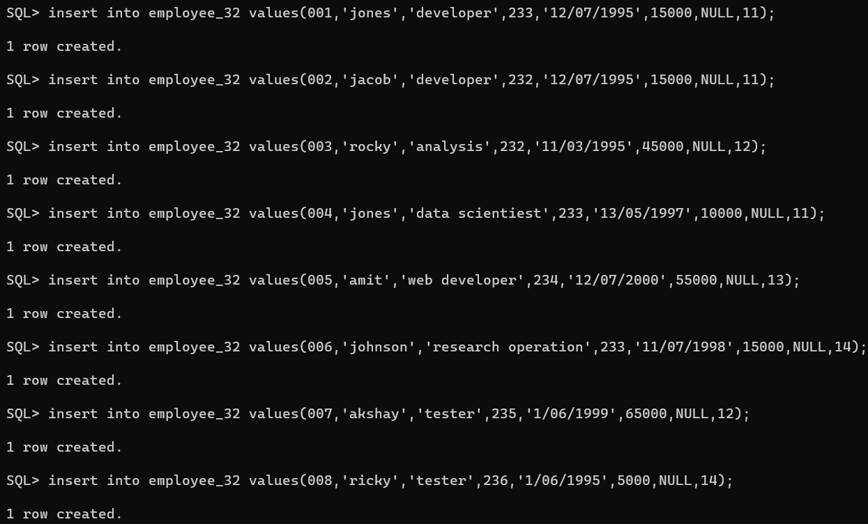

3. Write a query to display element in employee_65

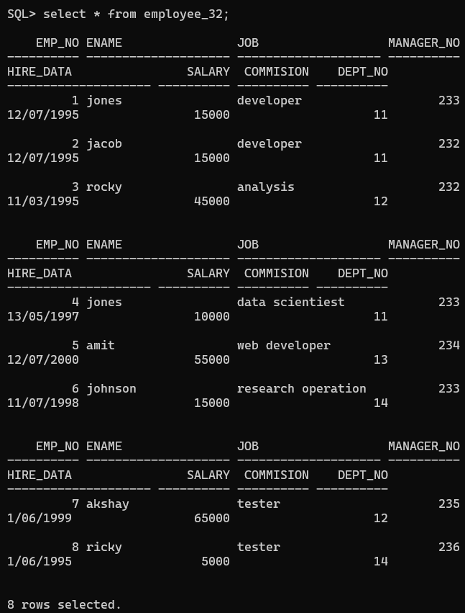

4. Write a to display employee_65 using Rank order by salary

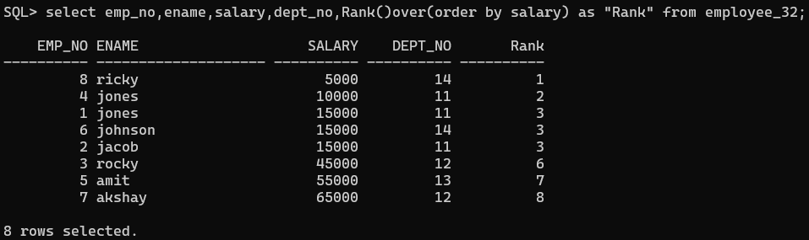

5. Write a to display employee_65 using Rank order by salary and partition by dept_no

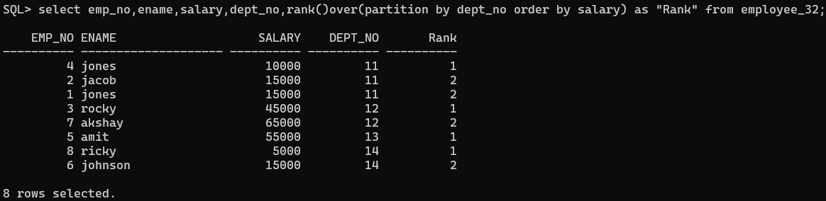

6. Write a to display employee_65 using Rank order by salary desc and partition by dept_no

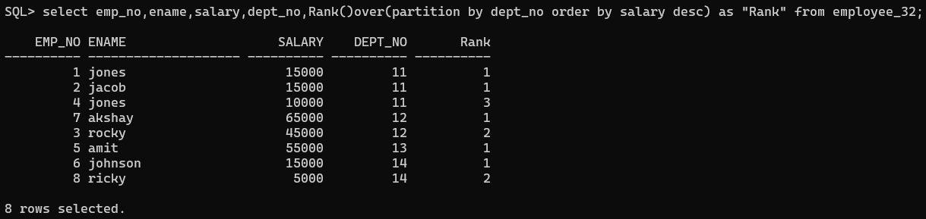

7. Write a to display employee_65 using Dense_Rank order by salary desc and partition by dept_no

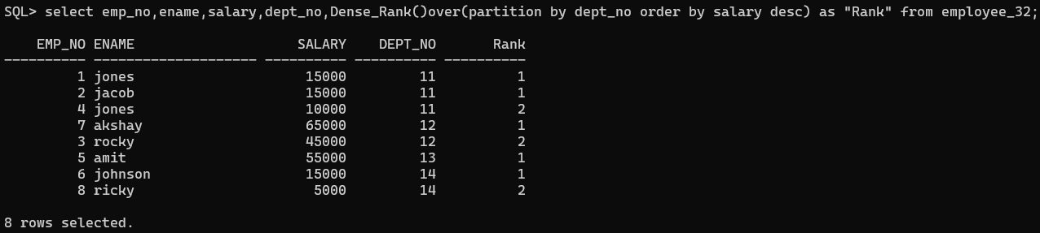

8. Display the highest and the lowest salary of the employee within their department order by dept_no and salary. Min and max first value and last value

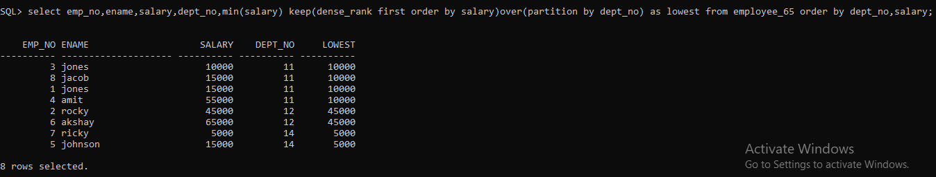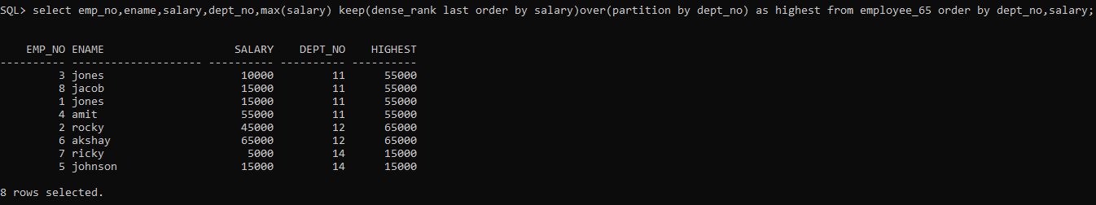

9. Write a query to display a row number.

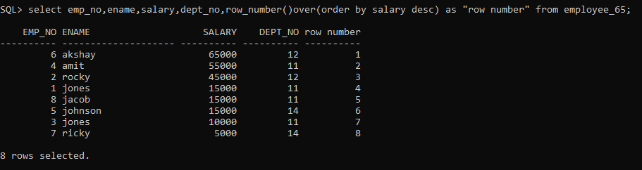

10. Without Partition

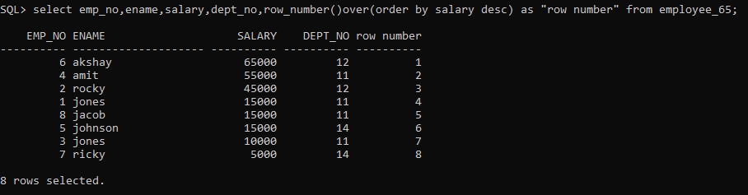

11. Print the average salary of department.

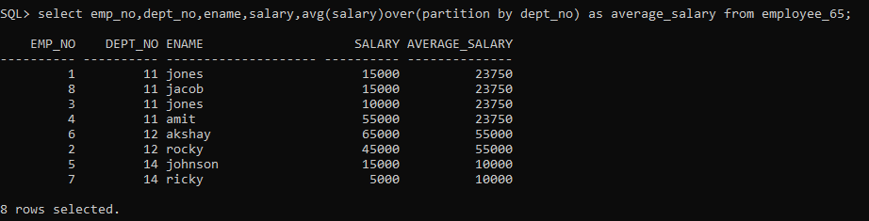

12. Find out the sum of the salary, dept_no and job wise

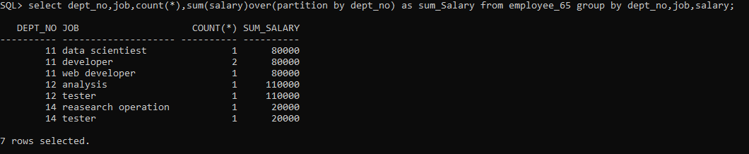

13. Group by function Cube.

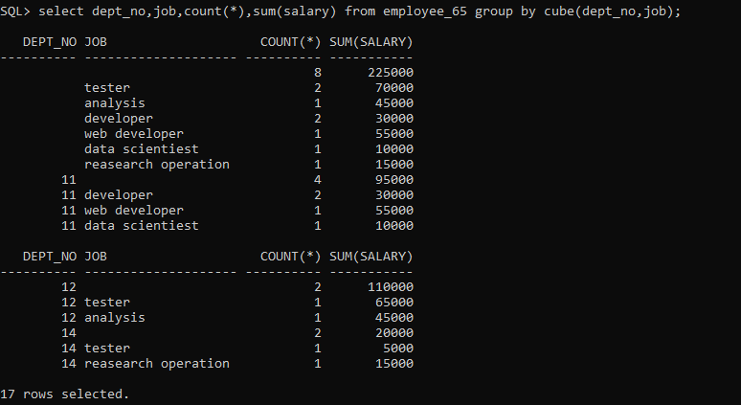

Practical 3

Implementation of ORDBMS(Object)

Implementation of ORDBMS using ADT(Abstract Data Types), References, etc.

* Abstract data types

1. Create data type type_name and type_address





2. Create table.



3. Insert data into the table.





4. Show inserted data from the table.

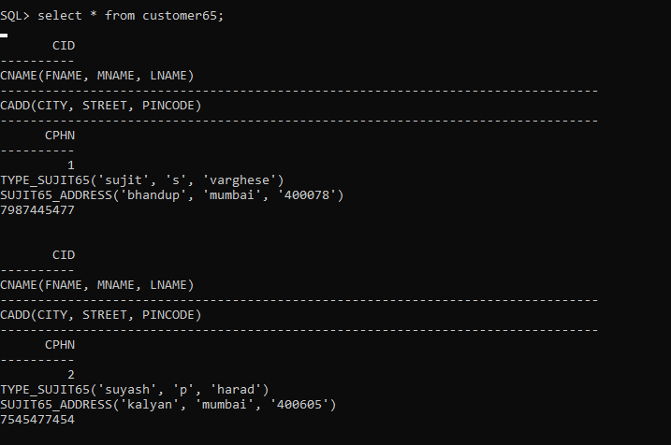

5. Describe the table created.

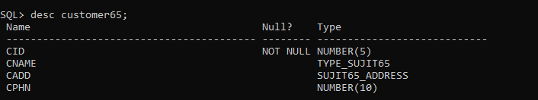

6. Display the name of the street from the table where the cid=1.

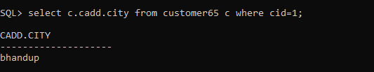

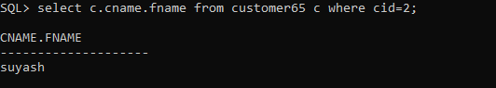

7. Display the first name from the table where the cid=1.

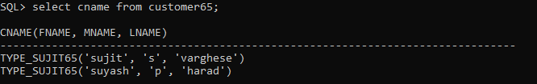

8. Display the full name from the table.

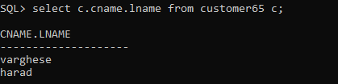

9. Display the first name, middle name and last name from the table.

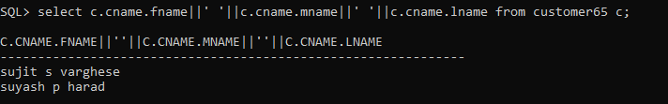

2. REF and DREF function

1. Create object table



2. Create table

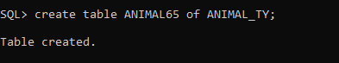

3. Insert rows into table.

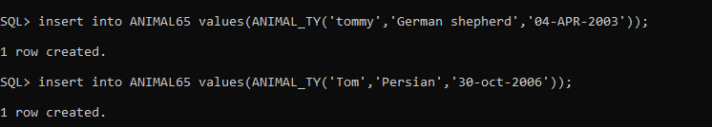

4. REF function

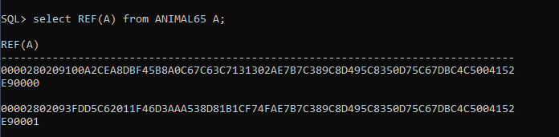

Using DREF function

5.Create a table with the name KEEPER.

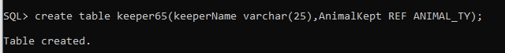

6. Describe keeper table

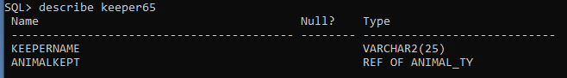

7. Insert values into that table



8. Show values inserted into the table keeper

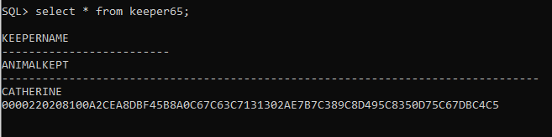

9. Select keeperName, deref(k.Animalkept) from keeper65 k

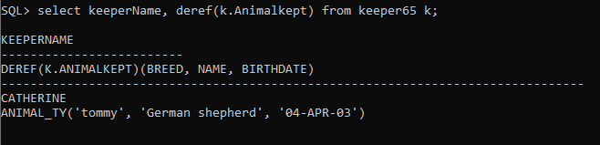

Practical 4

Introduction to R Programming and data acquisition.

Basics of R



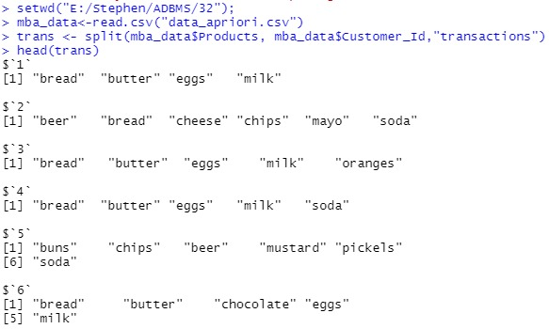

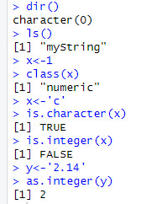

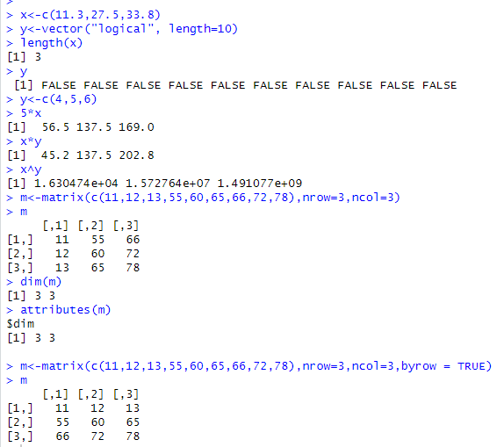

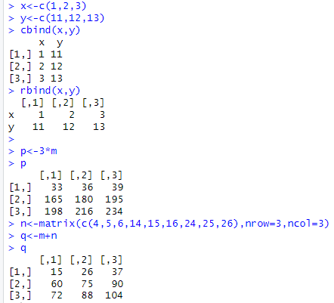

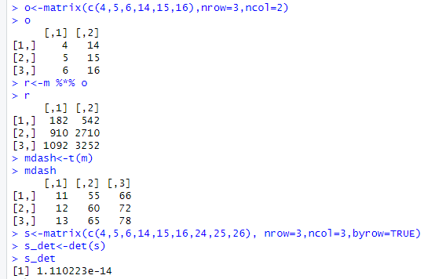

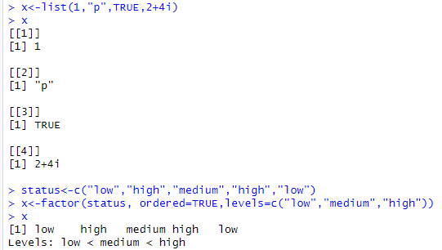

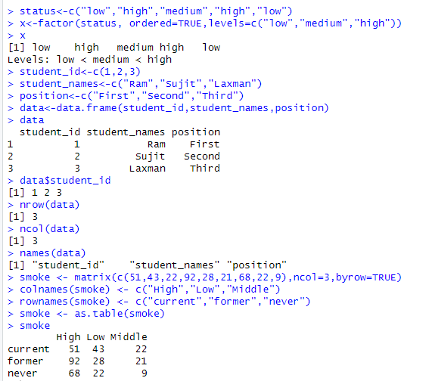

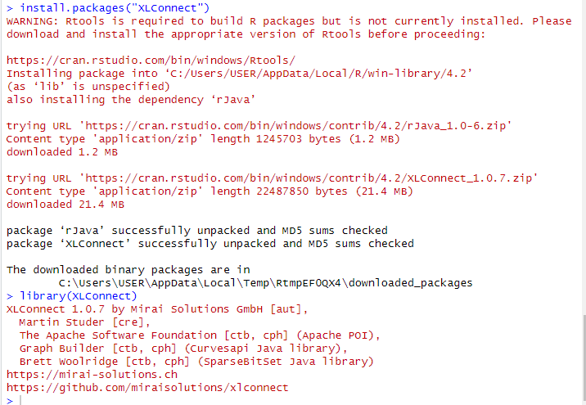

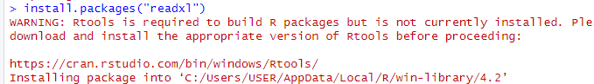



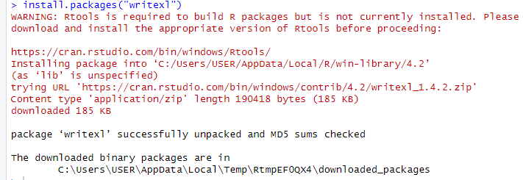



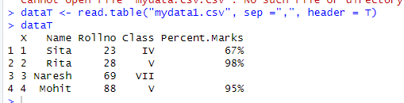

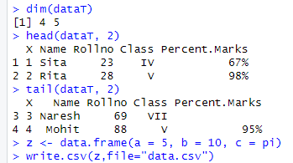

**Reading and writing data from Excel using XLConnect**



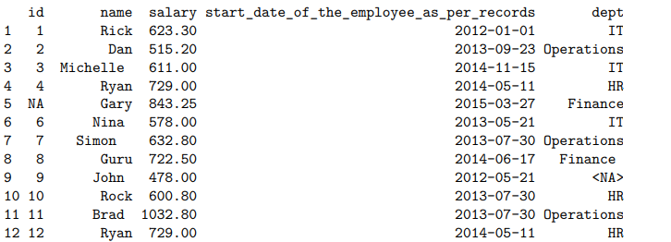

**Reading and writing data from Excel using readXL and writeXL**

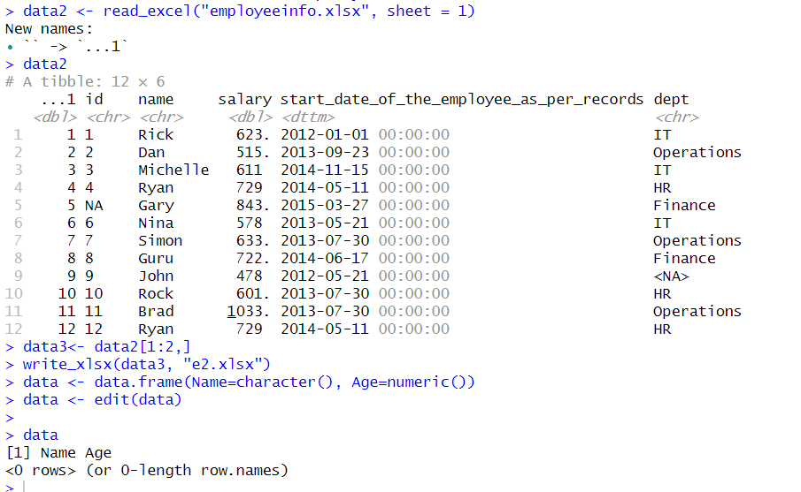



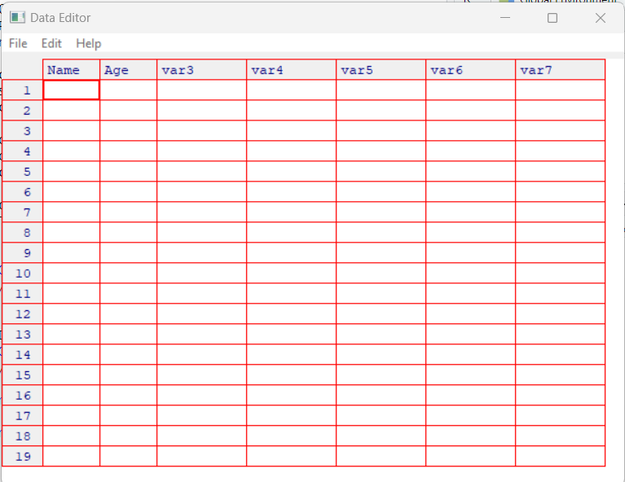

Practical 5

Implementation of Data Preprocessing techniques.

Implementation of Data preprocessing techniques like,

1. Naming and Renaming variables, adding a new variable.

2. Dealing with missing data.

3. Dealing with categorical data.

4. Data reduction using subsetting.



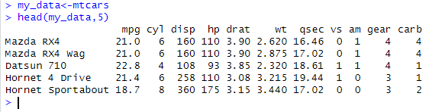

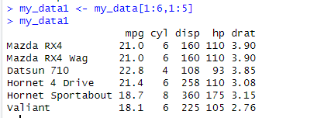

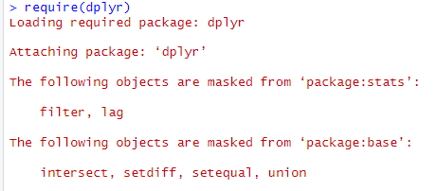

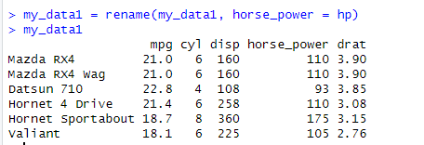

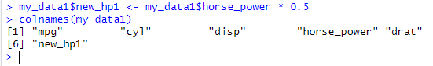

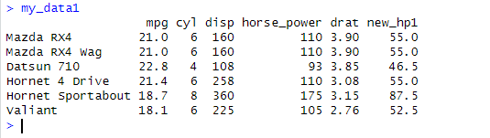

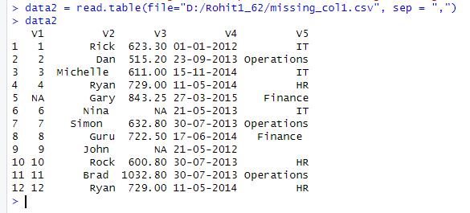

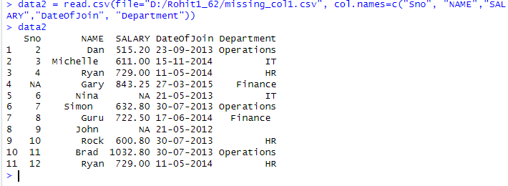

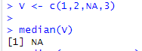





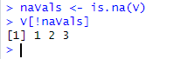



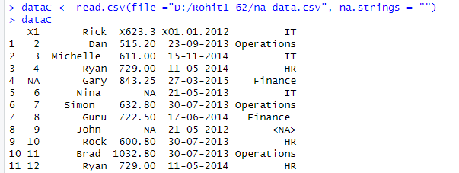

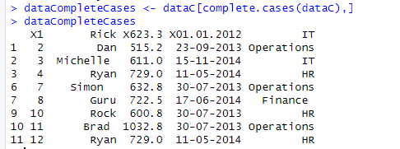

Imputation

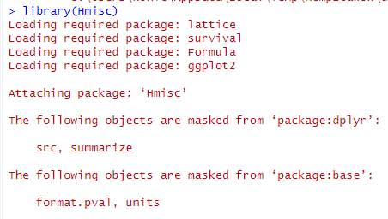

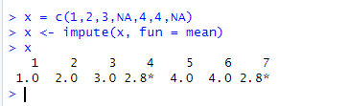

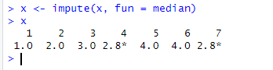

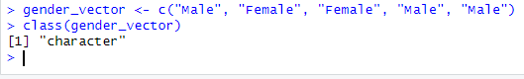

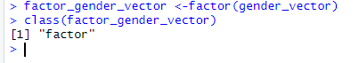

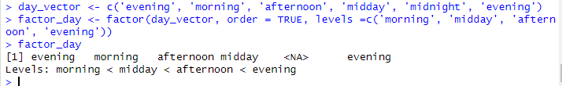

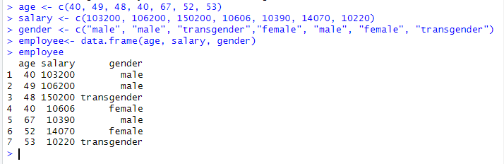

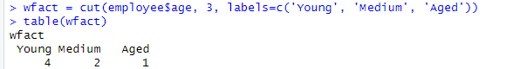

Practical 6

Implementation and analysis of Linear regression through graphical methods including Plots

Regression Analysis:

Implementation and analysis of Linear regression through graphical methods including Plots.

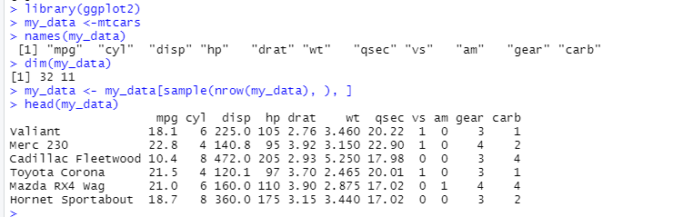

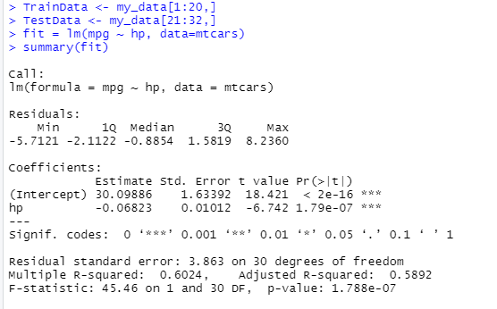

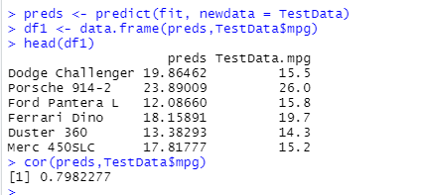



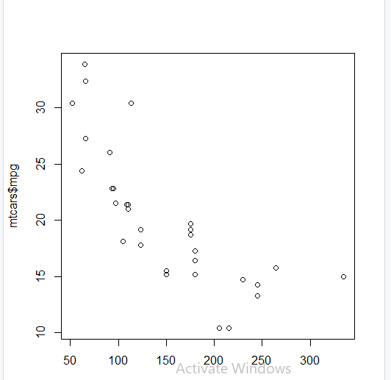

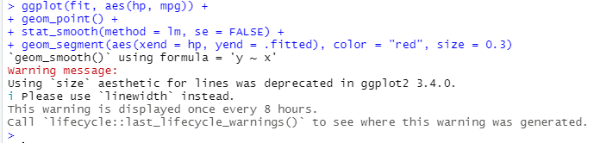

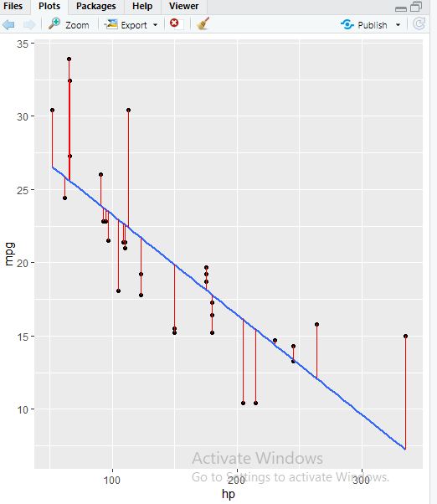

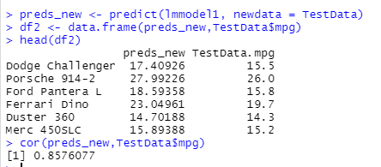



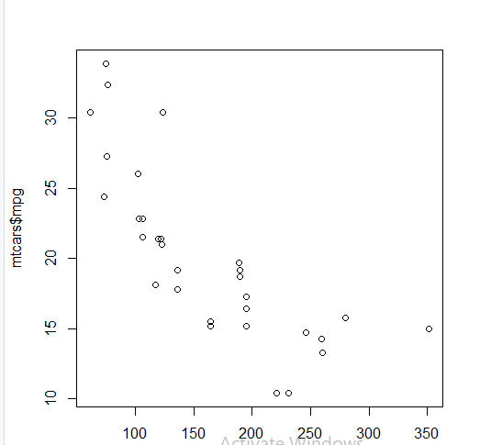

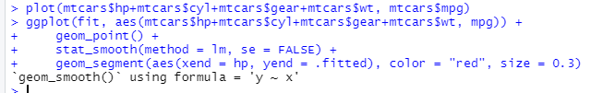

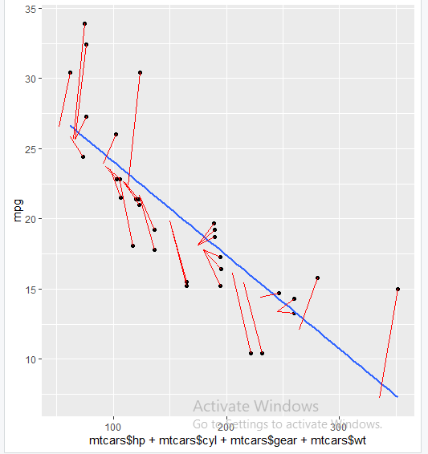

Practical 7

Implementation and analysis of Classification and algorithms.

Classification:

Implementation and analysis of Classification algorithms like

1. Naive Bayesian,

2. K-Nearest Neighbor

3. ID3

4. C4.5

Naive Bayes

• Based on the Bayes theorem

• Predicts based on probabilities from training

data P(B|A) = P(A|B) P(B)/P(A)

Gives posterior probability of ‘B’ given ‘A’ using prior probability of ‘B’ prior probability of ‘A’ and conditional probability of ‘A’ given ‘B’.

• Takes two step approach

– Calculates the posterior probability of the Class given the input - for every class

– Assigns the class with higher posterior probability

• More suited when dimensionality of input is high the - widely used for document classification

• Also good for the multiclass classifications

• Works well with less datasets also, but the assumption that predictor variables are independent should hold.

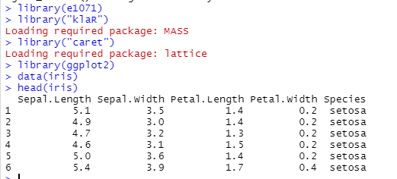

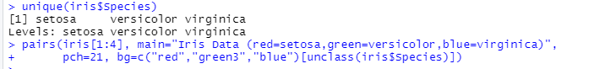

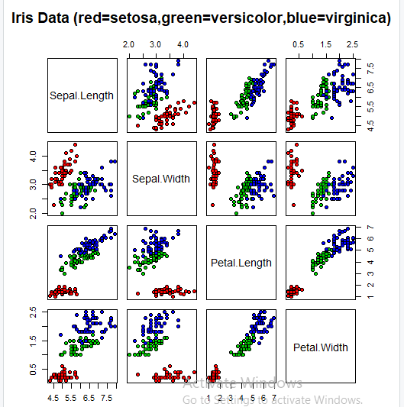

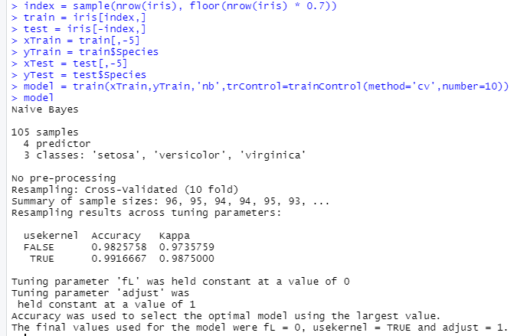

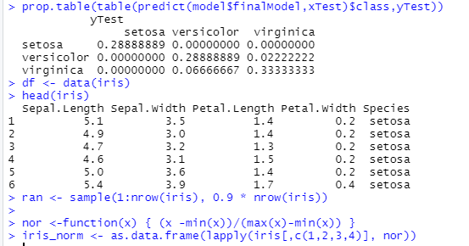

K Nearest Neighbour

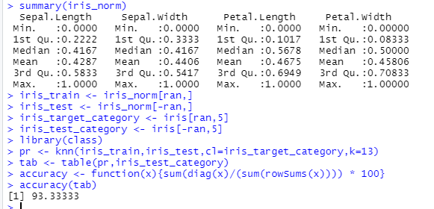

Practical 8

Implementation and analysis of Apriori Algorithm using Market Basket Analysis

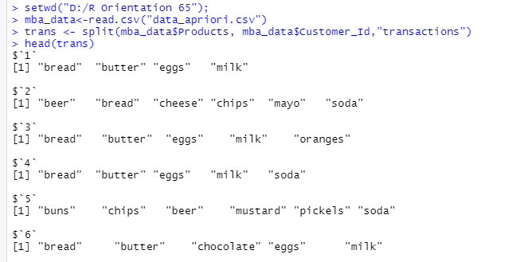

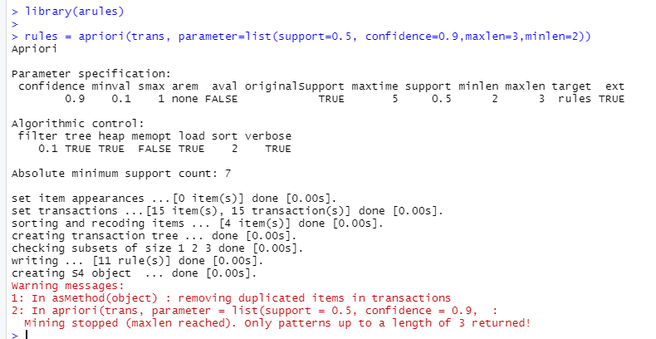

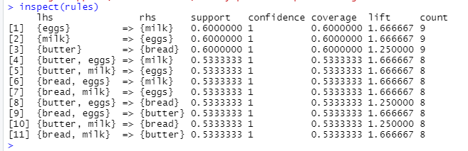

Practical 9

Implementation and analysis of clustering and algorithm.

Implementation and analysis of clustering algorithms like

1. K-Means

2. Agglomerative

**K Means Clustering**

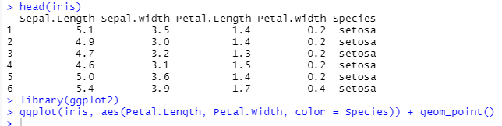

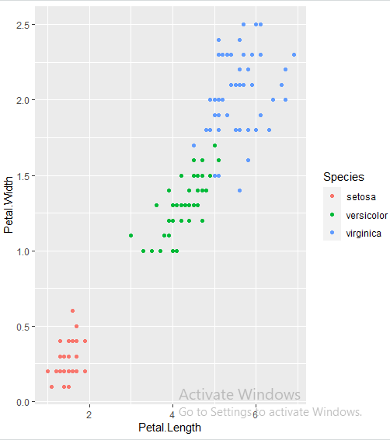

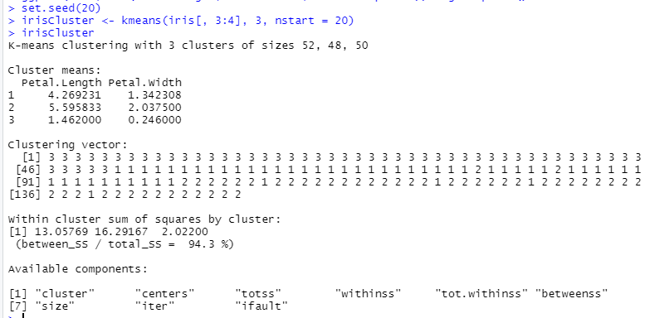



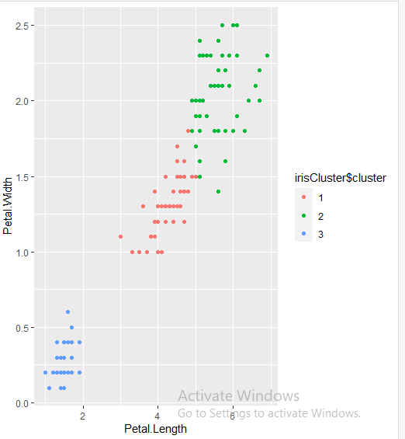

**Agglomerative Clustering**

